# Progress Report Industrial Training Project

**Undertaken at**

# Terminal Ballistic Research Laboratory, DRDO

### SUBMITTED IN PARTIAL FULFILLMENT OF THE REQUIREMENTS FOR THE AWARD OF

**THE DEGREE OF BACHELOR OF ENGINEERING**

### (Computer Science Engineering)

**Submitted To :**

Chandigarh College Of Engineering and Technology, Punjab University,

Chandigarh

### Submitted By :

Lalit Kumar ( CO20328 )

**Under the Guidance of:**

Sh. Ravidera Singh Technical Officer `B`, TBRL, DRDO

**CHANDIGARH COLLEGE OF ENGINEERING AND TECHNOLOGY (DEGREE WING)**

Government Instituteunder Chandigarh (UT) Administration |Affiliatedto Panjab University,

Chandigarh

Sector-26, Chandigarh. PIN-160019 | Tel. No. 0172-2750947, 2750943 Website: [www.ccet.ac.in |](http://www.ccet.ac.in/) Email: [principal@ccet.ac.in |](mailto:principal@ccet.ac.in) Fax. No**. :**0172-2750872

**Department of Computer Sc. & Engineering**

**CANDIDATE’S DECLARATION**

I hereby declare that the work presented in this report in fulfilment of the requirement for mid-term evaluation for the award of the degree Bachelor of Engineering in Computer Science & Engineering, submitted to CSE Department, Chandigarh College of Engineering & Technology (Degree wing) affiliated to Punjab University, Chandigarh, is an authentic record of my work carried out during my degree under the guidance of Sh Ravinder Singh Technical Officer `B`, TBRL. The work reported in this has not been submitted by me for the award of any other degree or diploma.

Date: April 2024 Lalit Kumar : CO20328

**CHANDIGARH COLLEGE OF ENGINEERING AND TECHNOLOGY (DEGREE WING)**

Government Instituteunder Chandigarh (UT) Administration |Affiliatedto Panjab University, Chandigarh

Sector-26, Chandigarh. PIN-160019 | Tel. No. 0172-2750947, 2750943 Website: [www.ccet.ac.in |](http://www.ccet.ac.in/) Email: [principal@ccet.ac.in |](mailto:principal@ccet.ac.in) Fax. No**. :**0172-2750872

## Department of Computer Sc. & Engineering

**CERTIFICATE**

This is to certify that this mid-term project work submitted by Lalit Kumar (Roll no. LCO20328), in fulfilment of the requirements for the award of a Bachelor of Engineering Degree in Computer Science & Engineering at Chandigarh College of Engineering and Technology (Degree Wing), Chandigarh, is an authentic work carried out by him under my supervision and guidance. To the best of my knowledge, the matter embodied in the project has not been submitted to any other University or Institute for the award of any degree.

Date 29-04-2024 Sh Ravinder Singh

Place:Ramgarh Technical Officer `B`

**CHANDIGARH COLLEGE OF ENGINEERING AND TECHNOLOGY (DEGREE WING)**

Government Instituteunder Chandigarh (UT) Administration |Affiliatedto Panjab University, Chandigarh

Sector-26, Chandigarh. PIN-160019 | Tel. No. 0172-2750947, 2750943 Website: [www.ccet.ac.in |](http://www.ccet.ac.in/) Email: [principal@ccet.ac.in |](mailto:principal@ccet.ac.in) Fax. No**. :**0172-2750872

**Department of Computer Sc. & Engineering**

**ACKNOWLEDGEMENT**

I would like to express my sincere gratitude to the Defence Research and Development Organization (DRDO) - Terminal Ballistics Research Laboratory (TBRL) for providing me with the opportunity to undertake a 6-month industrial training as part of my Bachelor's degree in Computer Science from Chandigarh College of Engineering and Technology.

During my internship at DRDO-TBRL, I have had the privilege to work under the guidance of experienced professionals and engage in meaningful projects that have enriched my learning experience and enhanced my skills in the field of computer science.

I am thankful for the support, encouragement, and knowledge imparted to me during this period, which has significantly contributed to my growth and development as a budding engineer. Special thanks to Sh Ravinder Singh for their mentorship and valuable insights throughout my internship.

I am truly grateful for this invaluable opportunity and look forward to applying the knowledge and skills gained here in my future endeavors.

Sincerely, Lalit Kumar

**CHANDIGARH COLLEGE OF ENGINEERING AND TECHNOLOGY (DEGREE WING)**

Government Instituteunder Chandigarh (UT) Administration| Affiliatedto Panjab University,

Chandigarh

Sector-26, Chandigarh. PIN-160019 | Tel. No. 0172-2750947, 2750943 Website: [www.ccet.ac.in |](http://www.ccet.ac.in/) Email: [principal@ccet.ac.in |](mailto:principal@ccet.ac.in) Fax. No**. :**0172-2750872

**Department of Computer Sc. & Engineering**

**ABSTRACT**

In high-velocity impact trials, precise analysis of vibration data is crucial for evaluating the structural integrity and performance of materials subjected to extreme conditions. Traditional methods often entail manual processing of data, leading to time-intensive procedures and limited insights. In this project, we introduce a specialized Vibration Analyzer tailored for high-velocity impact trials, offering efficient and comprehensive analysis capabilities.

The Vibration Analyzer provides a user-friendly interface for loading and visualizing vibration data obtained from impact trials. Through intuitive controls, users can adjust parameters such as sensitivity and sampling frequency to customize the analysis according to specific requirements. The tool facilitates the plotting of G-levels and Power Spectral Density (PSD) plots, enabling researchers to gain insights into the dynamic response of materials under high-velocity impact.

By integrating features such as zooming functionality and logarithmic scaling of plots, the Vibration Analyzer enhances the visualization and interpretation of vibration data, allowing researchers to identify critical patterns and anomalies with ease. Furthermore, the tool offers functionalities for generating project reports and abstracts, streamlining the documentation process and facilitating knowledge dissemination.

Overall, the Vibration Analyzer serves as a valuable asset in high-velocity impact trials, empowering researchers with advanced analysis capabilities to enhance the understanding of material behavior and optimize designs for military and aerospace applications.

**Table Of Contents**

|  |  |  |
| --- | --- | --- |
| **Sno.** | **Chapters** | **Pageno.** |
| **1.** | **Introduction** | **7-10** |
| **2.** | **Domain Knowledge of**  **HEMs** | **11-14** |
| **3.** | **Properties of Interest and**  **Explo 5** | **15-28** |
| **4** | **Composing Dataset** | **29-38** |
| **5** | **Prediciton Process** | **39-43** |
| **6.** | **Conclusion** | **44** |

**Chapter 1. Introduction**

### About the Organization

* + 1. **DRDO**

The Defence Research and Development Organization (DRDO) is an Indian government agency responsible for military research and development. It was founded in 1958 with the vision of enhancing self-reliance in defense systems and promoting cutting-edge technologies for national security. DRDO operates under the Ministry of Defence, Government of India.

Here are some key points about DRDO:

**Mission and Objectives:** DRDO's primary mission is to design, develop, and lead the production of state-of-the-art defense technologies and systems for the Indian Armed Forces. Its objectives include developing indigenous defense capabilities, reducing dependency on foreign suppliers, and enhancing the country's defense preparedness.

**Research and Development Areas:** DRDO is involved in a wide range of research and development activities spanning various domains such as aeronautics, missiles, naval systems, electronics and communication, combat vehicles, armaments, life sciences, and more. It works on projects ranging from basic research to advanced technology development and system integration.

**Achievements:** DRDO has achieved significant milestones in defense technology over the years. Some notable achievements include the development of strategic missiles like Agni, Prithvi, and BrahMos, the Light Combat Aircraft (LCA) Tejas, various radar and surveillance systems, electronic warfare systems, and advanced communication technologies.

**Collaborations and Partnerships:** DRDO collaborates with various national and international institutions, academia, and industries to leverage expertise and resources. It also engages in technology transfer and joint development programs to foster innovation and speed up the development process.

**Laboratories and Centers:** DRDO operates through a network of specialized laboratories and research centers across India. These facilities are equipped with state- of-the-art infrastructure and skilled personnel dedicated to research, testing, and validation of defense technologies.

**Future Focus:** DRDO continues to focus on futuristic technologies such as artificial intelligence, robotics, cyber defense, quantum computing, hypersonic systems, and space-based applications for defense purposes. It aims to stay at the forefront of technological advancements to meet the evolving challenges of modern warfare.

Overall, DRDO plays a crucial role in India's defense ecosystem by spearheading research and development efforts to strengthen national security and contribute to the country's defense capabilities.

### TBRL

The Terminal Ballistic Research Laboratory (TBRL) is a premier research and development institution under the Defence Research and Development Organisation (DRDO) of India. TBRL is dedicated to the study and development of terminal ballistic technologies, which primarily involve the behavior of projectiles, explosives, and their effects on targets.

Here are some key points about TBRL:

**Mission and Focus:** TBRL's mission is to conduct research, development, and testing of technologies related to terminal ballistics. This includes studying the performance of ammunition, projectiles, warheads, explosives, and their interactions with various targets such as armor, structures, and materials.

**Research Areas:** TBRL focuses on a wide range of research areas within terminal ballistics, including:

1. Projectile design and performance analysis.
2. Explosive formulations and detonation studies. 3 Impact dynamics and penetration mechanics.
3. Blast and fragmentation effects.
4. High-speed photography and instrumentation for data collection.

**Capabilities:** TBRL is equipped with advanced testing facilities, laboratories, and instrumentation to carry out experiments and evaluations related to terminal ballistics. This includes high-speed ballistic ranges, shock tube facilities, explosive test chambers, material testing laboratories, and computational modeling capabilities.

**Collaborations and Projects:** TBRL collaborates with various defense organizations, research institutions, and industries to work on projects related to weapon systems development, armor design, blast protection, explosive ordnance disposal, and countermeasures against ballistic threats.

**Contributions to Defense:** TBRL's research and development efforts contribute significantly to enhancing the effectiveness, reliability, and safety of defense systems and munitions used by the Indian Armed Forces. This includes improving the performance of artillery shells, missile warheads, armor-piercing projectiles, and protective materials.

**Future Directions:** TBRL continues to innovate and explore new technologies in terminal ballistics, including advanced materials for armor, precision-guided munitions, non-lethal weapons, and countermeasures against emerging threats.

In summary, TBRL plays a critical role in advancing terminal ballistic technologies for defense applications, supporting India's national security objectives, and ensuring the efficiency and efficacy of military systems and munitions.

### My Role and Responsibilities

As a software developer for the Vibration Analyzer project, my role encompasses several key responsibilities essential for the development and enhancement of the tool. Here's a detailed breakdown:

1. **Software Analysis and Study**:
   * Conducting in-depth analysis of software requirements and user needs to ensure alignment with the objectives of the Vibration Analyzer project.
   * Studying the Power Spectral Density (PSD) data and its significance in vibration analysis to inform software design decisions and feature implementations.
2. **Feature Engineering**:
   * Identifying and implementing relevant features within the Vibration Analyzer tool to enhance its functionality and usability.
   * Developing algorithms and methods to accurately process and visualize PSD data for effective analysis by users.
3. **User Interface Development**:
   * Designing and developing the graphical user interface (GUI) of the Vibration Analyzer tool to provide an intuitive and seamless user experience.
   * Incorporating user feedback and usability studies to refine the interface and improve user interaction with the software.
4. **Plotting and Visualization**:
   * Implementing plotting and visualization functionalities within the tool to enable users to analyze PSD data and interpret results.
   * Ensuring that the visual representations of PSD data are clear, informative, and aligned with industry standards and best practices.
5. **Integration with External Libraries and Tools**:
   * Integrating external libraries and tools, such as Matplotlib and Pandas, to enhance the analytical capabilities of the Vibration Analyzer.
   * Leveraging the functionalities provided by these libraries to optimize data processing and visualization tasks within the tool.
6. **Testing and Quality Assurance**:
   * Conducting thorough testing of the software to identify and rectify any bugs, errors, or inconsistencies in the code.
   * Implementing robust quality assurance measures to ensure the reliability and stability of the Vibration Analyzer tool under various usage scenarios.
7. **Documentation and Maintenance**:
   * Documenting the codebase, including comments, README files, and user manuals, to facilitate understanding and usage by other developers and end-users.
   * Providing ongoing maintenance and support for the tool, including updates, bug fixes, and feature enhancements, as per user feedback and evolving requirements.

By diligently fulfilling these responsibilities, I aim to contribute to the development of a reliable and efficient Vibration Analyzer tool that meets the needs of users involved in vibration analysis tasks, particularly in analyzing Power Spectral Density data for insights and decision-making.

# Chapter 2: Domain Knowledge on Viberational Analysis

**Vibration analysis is a crucial aspect of engineering and scientific disciplines that deals with the study of oscillatory motion and its effects on mechanical systems, structures, and human beings. This comprehensive domain knowledge report aims to provide a detailed understanding of two fundamental concepts in vibration analysis: G-levels and Power Spectral Density (PSD).**

#### 2.1 G-levels

##### 2.1.1 Definition

G-levels, also known as gravitational levels, represent the magnitude of acceleration experienced by a vibrating system. They are typically measured in units of g, which is the standard acceleration due to gravity (9.81 m/s²).

##### 2.1.2 Importance in Vibration Analysis

G-levels play a critical role in vibration analysis as they help quantify the intensity of vibration and its potential impact on structures, equipment, and human occupants. Understanding G-levels enables engineers to assess the dynamic behavior of mechanical systems, identify potential sources of vibration, and evaluate the structural integrity of components.

##### 2.1.3 Measurement Techniques

Various techniques are available for measuring G-levels, including the use of accelerometers, seismometers, and other specialized sensors. Accelerometers are the most commonly used devices, capable of accurately detecting and recording acceleration levels across different frequency ranges.

#### 2.2 Power Spectral Density (PSD)

##### 2.2.1 Definition

Power Spectral Density (PSD) is a frequency-domain representation of the distribution of power or energy in a signal across different frequencies. It provides valuable insights into the frequency content and energy distribution of a vibrating system.

##### 2.2.2 Calculation Methods

Several methods exist for calculating PSD, each with its own advantages and limitations. Some of the commonly used methods include:

##### 2.2.2.1 Periodogram

The periodogram is a straightforward method for estimating the PSD of a signal by computing the squared magnitude of its Discrete Fourier Transform (DFT). While simple to implement, the periodogram suffers from high variance, especially when applied to short or noisy signals.

##### 2.2.2.2 Welch Method

The Welch method is an improvement over the periodogram that involves dividing the signal into overlapping segments, computing the periodogram for each segment, and averaging the results to obtain a smoothed estimate of the PSD. This approach helps reduce variance and improve the accuracy of the PSD estimate, particularly for non-stationary signals or those containing noise.

##### 2.2.2.3 Burg Method

The Burg method is a parametric approach to PSD estimation that models the signal as an autoregressive (AR) process. It iteratively estimates the AR coefficients using the Yule-Walker equations and computes the PSD from the resulting model parameters.

##### 2.2.2.4 Maximum Entropy Method

The Maximum Entropy Method (MEM) is another parametric technique for PSD estimation that seeks to find the spectral density function that maximizes the entropy while satisfying a set of constraints defined by the available data. MEM is particularly useful when dealing with short or unevenly spaced datasets.

### 2.3 Applications of Vibration Analysis

Vibration analysis has widespread applications across various industries and domains, including:

* Structural Health Monitoring (SHM) of bridges, buildings, and other infrastructure.
* Machinery Condition Monitoring (MCM) in industrial plants, factories, and manufacturing facilities.
* Aerospace and Defense for evaluating the performance and reliability of aircraft, spacecraft, and military vehicles.

### 2.4. G-levels in Detail

#### 2.4.1 Definition and Concept

G-levels, or gravitational levels, quantify the magnitude of acceleration experienced by a vibrating system. They are typically measured in units of g, where 1 g corresponds to the acceleration due to gravity.

#### 2.4.2 Measurement Techniques

##### 2.4.2.1 Accelerometers

Accelerometers are widely used sensors for measuring G-levels in vibration analysis. These devices contain a mass suspended by a spring, which generates an electrical signal proportional to the applied acceleration.

##### 2.4.2.2 Seismometers

Seismometers are specialized sensors designed for detecting and recording ground vibrations caused by seismic events, such as earthquakes and volcanic eruptions. They operate on similar principles to accelerometers but are optimized for low-frequency, high-amplitude motions.

##### 2.4.2.3 Other Sensors

In addition to accelerometers and seismometers, other sensors such as piezoelectric sensors, strain gauges, and gyroscopes may also be used for measuring G-levels in specific applications.

#### 2.4.3 Interpretation of G-level Data

##### 2.4.3.1 Threshold Values

Depending on the application and industry standards, specific threshold values may be defined for acceptable G-levels to ensure the safety and reliability of structures and equipment.

##### 2.4.3.2 Impact on Structures and Equipment

Excessive G-levels can lead to structural damage, equipment failure, and safety hazards, highlighting the importance of monitoring and controlling vibration levels in various systems.

##### 2.4.3.3 Human Response Criteria

Human response criteria, such as ISO 2631, provide guidelines for assessing the effects of vibration on human comfort, performance, and health. These criteria consider factors such as vibration frequency, duration, and amplitude in determining acceptable exposure levels.

### 2.5. Power Spectral Density (PSD) Explained

#### 2.5.1 Definition and Concept

Power Spectral Density (PSD) is a fundamental concept in signal processing that quantifies the distribution of power or energy in a signal across different frequencies.

#### 2.5.2 Importance in Vibration Analysis

PSD analysis provides valuable insights into the frequency content and energy distribution of a vibrating system, helping engineers and analysts identify dominant frequencies, resonant modes, and potential sources of vibration.

#### 2.5.3 Calculation Methods

##### 2.5.3.1 Periodogram

The periodogram is a straightforward method for estimating the PSD of a signal by computing the squared magnitude of its Discrete Fourier Transform (DFT). While simple to implement, the periodogram suffers from high variance, especially when applied to short or noisy signals.

##### 2.5.3.2 Welch Method

The Welch method is an improvement over the periodogram that involves dividing the signal into overlapping segments, computing the periodogram for each segment, and averaging the results to obtain a smoothed estimate of the PSD. This approach helps reduce variance and improve the accuracy of the PSD estimate, particularly for non-stationary signals or those containing noise.

##### 2.5.3.3 Burg Method

The Burg method is a parametric approach to PSD estimation that models the signal as an autoregressive (AR) process. It iteratively estimates the AR coefficients using the Yule-Walker equations and computes the PSD from the resulting model parameters.

##### 2.5.3.4 Maximum Entropy Method

The Maximum Entropy Method (MEM) is another parametric technique for PSD estimation that seeks to find the spectral density function that maximizes the entropy while satisfying a set of constraints defined by the available data. MEM is particularly useful when dealing with short or unevenly spaced datasets.

### 2.6. Practical Implementation and Case Studies

Vibration analysis techniques, including the measurement and interpretation of G-levels and PSD, find practical application in various real-world scenarios, such as:

#### 2.6.1 Case Study 1: Structural Health Monitoring of Bridges

In this case study, vibration sensors are deployed on bridges to monitor their dynamic behavior and structural integrity. By analyzing G-levels and PSD data, engineers can detect anomalies, assess the condition of bridge components, and prioritize maintenance and repair activities.

#### 2.6.2 Case Study 2: Machinery Condition Monitoring in Industrial Plants

Industrial plants and factories use vibration analysis techniques to monitor the health of machinery and equipment, such as pumps, motors, and turbines. By analyzing G-levels and PSD data collected from sensors installed on rotating machinery, maintenance teams can detect early signs of degradation, prevent unplanned downtime, and optimize asset performance.

#### 2.6.3 Case Study 3: Vibration Analysis in Aerospace Applications

In aerospace and defense applications, vibration analysis plays a crucial role in evaluating the performance and reliability of aircraft, spacecraft, and military vehicles. By analyzing G-levels and PSD data collected during flight tests and ground simulations, aerospace engineers can assess structural integrity, identify potential failure modes, and optimize design parameters to enhance safety and performance.

### 2.7. Challenges and Future Directions

Despite its widespread use and practical applications, vibration analysis faces several challenges and opportunities for future research and development, including:

#### 2.7.1 Data Quality and Noise Reduction

#### 2.7.2 Integration with IoT and Big Data Analytics

#### 2.7.3 Advancements in Sensor Technology

This detailed domain knowledge report provides a thorough exploration of vibration analysis, covering essential concepts such as G-levels, PSD, measurement techniques, practical applications, challenges, and future directions. By enhancing understanding and awareness of these topics, stakeholders can make informed decisions and drive advancements in the field of vibration analysis.

# Chapter 3. Properties Of Interest

There are specific properties of HEMs which are very important to evaluate the performance of explosives these properties will be our central interests. These include:

### Friction Sensitivity

Friction sensitivity refers to the propensity of a material to undergo an exothermic reaction, combustion, or detonation when subjected to frictional forces. This sensitivity is a critical characteristic of high-energy materials (HEMs) and is influenced by various factors, including composition, physical form, particle size, morphology, and surface properties. Here's a detailed explanation of friction sensitivity:

#### Factors Influencing Friction Sensitivity:

**Chemical Composition:** The chemical composition of a material plays a significant role in its friction sensitivity. Certain chemical groups, functional moieties, or energetic components within the material may contribute to increased sensitivity to friction.

Materials containing nitro, nitrate, nitramine, or azide groups are often more friction- sensitive due to their energetic nature and susceptibility to mechanical activation.

**Physical Form:** The physical form of a material, such as solid, liquid, or powder, can affect its friction sensitivity. Finely divided powders or particulate materials are generally more sensitive to friction than bulk solids or liquids.

The surface area-to-volume ratio increases with decreasing particle size, leading to enhanced reactivity and susceptibility to friction-induced ignition or initiation.

**Particle Size and Morphology:** Smaller particle sizes and irregular morphologies (e.g., porous, rough surfaces) can increase friction sensitivity by promoting intimate contact between particles and enhancing mechanical energy transfer during frictional events.

Agglomerates, clusters, or aggregates of particles may exhibit localized hot spots or areas of increased reactivity, contributing to friction-induced reactions.

**Impurities and Additives:** Presence of impurities, contaminants, or reactive additives in the material can influence friction sensitivity. Impurities may act as sensitizers or catalysts for friction-induced reactions, leading to lowered ignition thresholds.

Additives such as lubricants, binders, stabilizers, or inert fillers may modify friction sensitivity by altering the material's mechanical properties, surface characteristics, or chemical interactions.

#### Mechanisms of Friction Sensitivity:

**Mechanical Energy Transfer:** Frictional forces applied to a material result in mechanical energy transfer, causing deformation, shearing, grinding, or impact on the material's surface.

Mechanical energy can lead to localized heating, pressure buildup, microstructural changes, and activation of chemical reactions or decomposition pathways within the material.

**Heat Generation:** Frictional contact generates heat due to frictional work, adiabatic heating, and deformation energy conversion.

Elevated temperatures at friction interfaces can promote thermal decomposition, ignition, or thermal runaway reactions in friction-sensitive materials.

**Chemical Activation:** Friction can induce chemical activation of reactive functional groups or energetic components within the material.

Molecular rearrangements, bond scission, radical formation, and energy release mechanisms may be triggered by mechanical stresses and friction-induced shear forces.

#### Measurement and Assessment of Friction Sensitivity:

**Friction Tests:** Friction sensitivity is often evaluated through standardized friction tests, such as the BAM friction tester, ABL friction tester, or modified Bruceton method.

These tests involve controlled application of frictional forces to a sample material under specified conditions (e.g., load, speed, surface roughness) to determine the likelihood of ignition or reaction initiation.

**Sensitivity Classifications:** Friction sensitivity data is typically used to classify materials into sensitivity categories, ranging from non-sensitive (insensitive to friction) to highly sensitive (prone to friction-induced reactions).

Classification criteria may include initiation threshold energy, ignition delay time, reaction severity, and hazard potential assessments.

#### Safety Considerations and Risk Mitigation:

**Handling Precautions:** Friction-sensitive materials require careful handling, storage, transportation, and processing to minimize risks of accidental ignition or initiation.

Use of appropriate containers, packaging, and handling procedures is essential to prevent frictional stimuli and mechanical shocks.

**Safety Testing:** Prior safety testing, risk assessments, and hazard analyses should be conducted to evaluate the friction sensitivity of materials and implement risk mitigation strategies.

Testing protocols may include sensitivity screening tests, compatibility studies, impact tests, and thermal stability assessments.

**Regulatory Compliance:** Compliance with regulatory standards, safety guidelines, and best practices for handling friction-sensitive materials is necessary to ensure workplace safety, environmental protection, and risk management.

Training personnel in safe handling practices, emergency response protocols, and hazard mitigation procedures is critical for reducing the likelihood of accidents and incidents involving friction-sensitive materials.

In summary, friction sensitivity is a crucial characteristic of high-energy materials, influenced by composition, physical properties, particle size, and surface interactions. Understanding the mechanisms, measurement techniques, safety considerations, and risk mitigation strategies associated with friction sensitivity is essential for safe handling and utilization of these materials in various industrial, defense, and research applications.

### Impact Sensitivity

Impact sensitivity refers to the propensity of a material to undergo an exothermic reaction, combustion, or detonation upon impact or mechanical shock. This sensitivity is a critical characteristic of high-energy materials (HEMs) and is influenced by various factors, including composition, physical form, particle size, morphology, and chemical reactivity. Here's a detailed explanation of impact sensitivity:

#### Factors Influencing Impact Sensitivity:

**Chemical Composition:** The chemical composition of a material plays a significant role in its impact sensitivity. Certain chemical groups, functional moieties, or energetic components within the material may contribute to increased sensitivity to mechanical shock.

Materials containing nitro, nitrate, nitramine, or peroxide groups are often more impact-sensitive due to their energetic nature and susceptibility to mechanical activation.

**Physical Form:** The physical form of a material, such as solid, liquid, or powder, can affect its impact sensitivity. Finely divided powders or particulate materials are generally more sensitive to impact than bulk solids or liquids.

The surface area-to-volume ratio increases with decreasing particle size, leading to enhanced reactivity and susceptibility to impact-induced initiation or detonation.

**Particle Size and Morphology:** Smaller particle sizes and irregular morphologies (e.g., porous, rough surfaces) can increase impact sensitivity by promoting intimate contact between particles and enhancing energy transfer during impact events.

Sharp edges, cracks, defects, or voids in the material's structure may act as initiation sites or stress concentrators, leading to localized reactions upon impact.

**Chemical Reactivity:** The intrinsic chemical reactivity of a material, including its decomposition pathways, reaction kinetics, and energy release mechanisms, influences impact sensitivity.

Materials with fast-reacting or highly exothermic decomposition processes are more likely to exhibit high impact sensitivity and rapid propagation of reactions upon mechanical shock.

#### Mechanisms of Impact Sensitivity:

**Mechanical Shock:** Impact sensitivity is primarily driven by mechanical shock or impact energy transferred to the material during handling, processing, or transportation.

Rapid deformation, compression, shear forces, and stress waves generated by impact can lead to energy localization, hot spot formation, and initiation of chemical reactions within the material.

**Frictional Heating:** Impact events can result in frictional heating at contact surfaces, leading to localized temperature spikes and thermal activation of reactive species or energetic components.

Friction-induced heating may enhance chemical reactivity, accelerate decomposition rates, and facilitate energy release in impact-sensitive materials.

**High Strain Rates:** Impact loading induces high strain rates and deformation rates in materials, causing structural changes, phase transitions, and energy dissipation mechanisms.

High strain rates can promote mechanical instabilities, shock-induced transformations, and initiation of shock-sensitive reactions in materials.

#### Measurement and Assessment of Impact Sensitivity:

**Impact Tests:** Impact sensitivity is evaluated through standardized impact tests, such as the BAM drop hammer test, Bruceton impact sensitivity test, and ball mill test.

These tests involve controlled application of impact energy to a sample material under specified conditions (e.g., drop height, impact velocity) to determine its likelihood of initiation or detonation.

**Sensitivity Classifications:** Impact sensitivity data is used to classify materials into sensitivity categories, ranging from non-sensitive (insensitive to impact) to highly sensitive (prone to impact-induced reactions).

Classification criteria may include impact initiation threshold energy, reaction severity, fragment size, and hazard potential assessments.

#### Safety Considerations and Risk Mitigation:

Prior safety testing, risk assessments, and hazard analyses should be conducted to evaluate the impact sensitivity of materials and implement risk mitigation strategies.

Testing protocols may include sensitivity screening tests, drop tests, impact tests, and compatibility studies to assess the material's response to mechanical shock.

Regulatory Compliance:

Compliance with regulatory standards, safety guidelines, and best practices for handling impact-sensitive materials is necessary to ensure workplace safety, environmental protection, and risk management.

Training personnel in safe handling practices, impact mitigation techniques, and emergency response protocols is critical for reducing the likelihood of accidents and incidents involving impact-sensitive materials.

In summary, impact sensitivity is a critical characteristic of high-energy materials, influenced by composition, physical properties, particle size, and chemical reactivity. Understanding the mechanisms, measurement techniques, safety considerations, and risk mitigation strategies associated with impact sensitivity is essential for safe handling and utilization of these materials in various industrial, defense, and research applications.

### Detonation Velocity

Detonation velocity refers to the speed at which a detonation wave propagates through a high-explosive material. This velocity is a critical parameter that characterizes the performance and behavior of explosives and is influenced by various factors, including chemical composition, physical properties, confinement conditions, and initiation methods. Here's a detailed explanation of detonation velocity:

#### Factors Influencing Detonation Velocity:

**Chemical Composition:**The chemical composition of an explosive material plays a significant role in determining detonation velocity. Materials with high energy content, such as nitro compounds (e.g., TNT, RDX, HMX), tend to exhibit higher detonation velocities.

The presence of oxygen-rich groups (e.g., nitrate, nitroso, perchlorate) and high nitrogen content contributes to faster energy release and propagation of detonation waves.

**Energy Density:** The energy density of an explosive, which is the amount of energy released per unit volume or mass, directly impacts detonation velocity. Higher energy density explosives typically have faster detonation velocities.

Energy density is influenced by the chemical structure, molecular weight, bond strength, and stoichiometry of the explosive composition.

**Confinement and Density:** Confinement conditions, such as the presence of a surrounding medium (e.g., air, water, soil) or confinement in a container or casing, can affect detonation velocity.

Confinement increases the pressure on the explosive material, leading to enhanced energy release and faster propagation of the detonation wave. Higher material densities also contribute to faster velocities.

**Initiation and Shockwave Characteristics:** The method of initiation, such as shock initiation, spark initiation, or pressure initiation, influences the characteristics of the detonation wave and its velocity.

Shockwave parameters, including pressure amplitude, duration, rise time, and waveform shape, impact the initiation and propagation of detonation waves in the explosive material.

**Temperature and Pressure:** Temperature and pressure conditions during detonation affect detonation velocity. Higher temperatures and pressures typically result in faster detonation velocities due to increased energy release and more favorable reaction kinetics.

The detonation velocity may vary with temperature and pressure, following complex thermodynamic and kinetic relationships.

#### Detonation Velocity Measurement:

**Experimental Methods:** Detonation velocity is measured experimentally using specialized equipment and techniques. Common methods include the use of detonation velocity gauges (DVGs), high-speed cameras, pressure sensors, and velocity interferometers.

Detonation velocity measurements are conducted under controlled conditions, varying parameters such as explosive mass, confinement geometry, initiation energy, and ambient conditions.

**Detonation Tests:** Detonation tests, such as cylinder tests, plate dent tests, and gap tests, are performed to determine the detonation velocity of explosive materials.

These tests involve initiating the explosive sample and measuring the time taken for the detonation wave to traverse a known distance, allowing for calculation of detonation velocity.

#### Importance of Detonation Velocity:

**Performance Evaluation:** Detonation velocity is a key parameter used to evaluate the performance, efficiency, and effectiveness of explosive materials. Higher detonation velocities indicate greater energy release and more rapid propagation of explosive effects.

It is used in comparative studies to assess the relative performance of different explosives, formulations, and compositions.

**Safety and Stability:** Knowledge of detonation velocity is essential for assessing the safety, stability, and handling characteristics of explosive materials.

Understanding detonation velocities helps in designing safe storage, transportation, and handling procedures, as well as predicting the potential hazards and risks associated with explosive use.

**Engineering Design:** Detonation velocity data is used in engineering design and analysis of explosive devices, munitions, warheads, propellants, and pyrotechnic systems.

It informs the design parameters, blast effects calculations, shockwave propagation models, and performance predictions in defense, aerospace, mining, and industrial applications.

**Research and Development:** In research and development of new explosive formulations, materials, and technologies, detonation velocity serves as a critical performance metric.

It guides the optimization, synthesis, testing, and validation of novel explosives with desired detonation characteristics for specific applications.

#### Variations and Limitations:

**Detonation Front Structure:** Detonation velocity may vary within the explosive material due to factors such as detonation front curvature, wave shape, reaction zone thickness, and energy release mechanisms.

Complex detonation front structures, including multiple waves or rarefaction zones, can affect the observed detonation velocity and its interpretation.

**Environmental Factors:** Environmental conditions, such as ambient temperature, humidity, altitude, and atmospheric pressure, can influence detonation velocity measurements and performance.

These factors may require corrections or adjustments to ensure accurate and consistent detonation velocity data under different operating conditions.

In summary, detonation velocity is a critical parameter that characterizes the performance, behavior, and safety considerations of explosive materials. Understanding the factors influencing detonation velocity, measurement techniques, applications, and limitations is essential for designing, testing, and utilizing explosives effectively in various fields, including defense, aerospace, mining, and industrial sectors.

### Heat of Formation

The heat of formation, also known as the standard enthalpy of formation (ΔH°f), is the enthalpy change that occurs when one mole of a compound is formed from its constituent elements in their standard states at a specified temperature and pressure. It is a fundamental thermodynamic property used to quantify the energy released or absorbed during a chemical reaction that forms a compound.

Here's a detailed explanation of the heat of formation:

#### Key Concepts:

**Enthalpy (H):** Enthalpy is a thermodynamic property that represents the total heat content of a system. It includes the internal energy of the system plus the product of pressure and volume.

Enthalpy changes (ΔH) are associated with energy exchanges during chemical reactions, phase transitions, and physical transformations.

**Standard States:** Standard states refer to the defined conditions under which enthalpy values are measured and compared. For gases, the standard state is usually 1 bar pressure, while for solids and liquids, it's typically the pure substance at a specified temperature.

Heat of Formation:

The heat of formation (ΔH°f) is the enthalpy change when one mole of a compound is formed from its constituent elements in their standard states.

The elements must be in their most stable forms at the specified temperature and pressure. For example, oxygen is diatomic (O2) in its standard state.

#### Calculation of Heat of Formation:

**Reaction Representation:** The heat of formation is calculated based on the reaction that forms the compound from its elements. The reaction is typically written in the form:

#### A + B + ... → Compound

Where A, B, etc., represent the elements in their standard states.

**Hess's Law:** Hess's Law states that the total enthalpy change of a reaction is independent of the pathway taken. This principle is applied to calculate the heat of formation.

If the heat of formation for each element is known, the heat of formation for the compound can be calculated using:

#### ΔH°f(Compound) = Σ(ΔH°f(products)) - Σ(ΔH°f(reactants))

Where Σ represents the summation over all products and reactants in the reaction.

**Reference Tables:** Heat of formation values for common compounds and elements are available in thermodynamic tables and databases. These values are determined experimentally or calculated using theoretical methods.

Values are often given in units of kilojoules per mole (kJ/mol) or kilocalories per mole (kcal/mol).

#### Significance and Applications:

**Energy Release/Absorption:** Positive ΔH°f values indicate that energy is absorbed during the formation of the compound, while negative values indicate energy release. Heat of formation values provide insights into the energy changes associated with chemical reactions, including exothermic (energy-releasing) and endothermic (energy-absorbing) processes.

**Thermochemical Calculations:** Heat of formation values are used in thermochemical calculations to determine reaction enthalpies, heat of reaction, heat of combustion, and heat of formation for complex reactions and systems.

These calculations are crucial in chemical engineering, combustion analysis, material synthesis, and energy conversion processes.

**Standardization:** Heat of formation values are used to standardize enthalpy data and establish reference points for comparing the energy content of different compounds and reactions.

Standard enthalpy of formation values are tabulated for a wide range of substances and are essential in thermodynamics, kinetics, and materials science.

**Chemical Stability:** The magnitude of the heat of formation can provide insights into the stability of compounds. Lower heat of formation values often indicate greater stability, while higher values may suggest higher reactivity or instability.

In summary, the heat of formation is a fundamental thermodynamic property that quantifies the energy changes associated with the formation of compounds from their constituent elements. It plays a vital role in energy calculations, reaction analysis, standardization of enthalpy data, and understanding the chemical stability and reactivity of substances.

### Detonation Pressure

The detonation pressure of an explosive refers to the pressure generated by the detonation wave as it propagates through the explosive material. It is a critical parameter that characterizes the explosive's performance, energy release, and blast effects. The detonation pressure depends on various factors, including the chemical composition of the explosive, the energy content, the rate of energy release, and the confinement conditions. Here's a detailed explanation of detonation pressure:

#### Key Concepts:

**Detonation Wave:** A detonation wave is a supersonic shockwave that travels through an explosive material at a speed faster than the speed of sound in that material. It is initiated by a high-energy source, such as a detonator or initiator.

**Shock Front:** The detonation wave creates a shock front that compresses and heats the explosive material rapidly. This leads to rapid energy release and the generation of high pressures and temperatures.

**Detonation Pressure:** Detonation pressure refers to the peak pressure achieved by the detonation wave as it travels through the explosive material. It is measured in units of pressure, such as pounds per square inch (psi) or megapascals (MPa).

#### Measurement and Prediction:

**Experimental Measurement:** Detonation pressure is measured experimentally using specialized equipment, such as pressure transducers, gauges, or high-speed cameras.

Detonation tests, such as cylinder tests, plate dent tests, or confined blast tests, are conducted to determine the peak pressure and pressure-time profiles during detonation.

**Theoretical Modeling:** The detonation pressure can be predicted using theoretical models and computational simulations based on the explosive's chemical kinetics, thermodynamics, and shockwave physics.

Models such as the Chapman-Jouguet (CJ) theory, Jones-Wilkins-Lee (JWL) equation of state, and hydrocode simulations are used to predict detonation pressures under different conditions.

#### Significance and Applications:

**Explosive Performance:** Detonation pressure is a key indicator of explosive performance, energy content, and effectiveness in generating blast effects. Higher detonation pressures are often associated with more powerful explosives.

It is used in comparative studies to assess the relative performance of different explosives, formulations, and compositions.

**Blast Effects:** The detonation pressure influences the magnitude and characteristics of blast effects, including shockwave intensity, blast wave propagation, fragmentation, cratering, and structural damage.

Understanding detonation pressures is crucial in designing explosive devices, munitions, warheads, propellants, and pyrotechnic systems for specific blast effects requirements.

**Engineering Design:** Detonation pressure data is used in engineering design and analysis of explosive devices, blast-resistant structures, protective barriers, and safety systems.

Shock sensitivity refers to the propensity of a material to undergo a rapid and violent reaction when subjected to a sudden mechanical shock or impact. This sensitivity is a

critical characteristic of high-energy materials (HEMs) and is influenced by various factors, including chemical composition, physical form, particle size, morphology, and energy content. Here's a detailed explanation of shock sensitivity:

#### Factors Influencing Shock Sensitivity:

**Chemical Composition:** The chemical composition of a material plays a significant role in its shock sensitivity. Certain chemical groups, functional moieties, or energetic components within the material may contribute to increased sensitivity to mechanical shock.

Materials containing nitro, nitrate, nitramine, or peroxide groups are often more shock-sensitive due to their energetic nature and susceptibility to rapid energy release.

**Energy Content:** The energy content of a material, which is related to its heat of formation, enthalpy, and combustion energy, influences shock sensitivity. Higher energy content materials tend to be more sensitive to shock due to the potential for rapid energy release.

Compounds with high energy density, such as high explosives, are particularly prone to shock-induced reactions.

**Physical Form:** The physical form of a material, including its state (solid, liquid, powder) and particle size, can affect shock sensitivity. Finely divided powders or particulate materials are generally more sensitive to shock than bulk solids or liquids. Smaller particle sizes increase the surface area-to-volume ratio, leading to enhanced reactivity and energy release upon shock impact.

**Particle Morphology:** The morphology of particles, such as shape, surface roughness, porosity, and crystallinity, can influence shock sensitivity. Irregular or rough surfaces may act as initiation sites for rapid energy release upon shock loading.

Porous structures or agglomerates within the material can create localized hot spots or areas of increased reactivity under shock conditions.

**Confinement and Containment:** Confinement conditions, such as the presence of a surrounding medium (e.g., air, water, soil) or confinement in a container or casing, can affect shock sensitivity.

Confinement may increase the pressure and energy transfer during shock events, leading to more intense reactions and higher sensitivity.

#### Mechanisms of Shock Sensitivity:

**Mechanical Energy Transfer:** Shock sensitivity is primarily driven by the rapid transfer of mechanical energy to the material during impact or shock events.

Sudden deformation, compression, shear forces, and stress waves generated by shock loading can lead to rapid energy release, phase transitions, and initiation of chemical reactions or decomposition pathways within the material.

**Energy Release and Activation:** Shock-induced deformation or stress can activate chemical bonds, functional groups, or energetic components within the material.

This activation leads to rapid energy release, exothermic reactions, bond scission, and generation of hot spots or reaction centers, contributing to shock-induced reactions.

**Phase Transitions:** Shock loading can induce phase transitions, structural changes, or solid-state transformations in materials, affecting their mechanical properties, reactivity, and sensitivity.

Phase transitions may involve changes in crystal lattice structures, polymorphic transitions, or amorphization, which influence shock response and energy dissipation mechanisms.

**Measurement and Assessment of Shock Sensitivity:** Shock Tests: Shock sensitivity is evaluated through specialized shock tests, such as the BAM impact sensitivity test, drop hammer tests, or plate dent tests.

These tests involve controlled application of mechanical shock or impact to a sample material under specified conditions (e.g., impact velocity, mass, geometry) to determine its likelihood of reaction, ignition, or decomposition.

**Sensitivity Classifications:** Shock sensitivity data is used to classify materials into sensitivity categories, ranging from non-sensitive (insensitive to shock) to highly sensitive (prone to shock-induced reactions).

Classification criteria may include initiation threshold energy, impact pressure, reaction severity, and hazard potential assessments.

It informs the design parameters, blast effects calculations, shockwave propagation models, and structural integrity assessments in defense, mining, demolition, and industrial applications.

### 3.7 EXPLO 5

Shock sensitivity refers to the propensity of a material to undergo a rapid and violent reaction when subjected to a sudden mechanical shock or impact. This sensitivity is a critical characteristic of high-energy materials (HEMs) and is influenced by various factors, including chemical composition, physical form, particle size, morphology, and energy content. Here's a detailed explanation of shock sensitivity:

#### Factors Influencing Shock Sensitivity:

**Chemical Composition:** The chemical composition of a material plays a significant role in its shock sensitivity. Certain chemical groups, functional moieties, or energetic components within the material may contribute to increased sensitivity to mechanical shock.

Materials containing nitro, nitrate, nitramine, or peroxide groups are often more shock-sensitive due to their energetic nature and susceptibility to rapid energy release.

**Energy Content:** The energy content of a material, which is related to its heat of formation, enthalpy, and combustion energy, influences shock sensitivity. Higher energy content materials tend to be more sensitive to shock due to the potential for rapid energy release.

Compounds with high energy density, such as high explosives, are particularly prone to shock-induced reactions.

**Physical Form:** The physical form of a material, including its state (solid, liquid, powder) and particle size, can affect shock sensitivity. Finely divided powders or particulate materials are generally more sensitive to shock than bulk solids or liquids. Smaller particle sizes increase the surface area-to-volume ratio, leading to enhanced reactivity and energy release upon shock impact.

**Particle Morphology:** The morphology of particles, such as shape, surface roughness, porosity, and crystallinity, can influence shock sensitivity. Irregular or rough surfaces may act as initiation sites for rapid energy release upon shock loading.

Porous structures or agglomerates within the material can create localized hot spots or areas of increased reactivity under shock conditions.

**Confinement and Containment:** Confinement conditions, such as the presence of a surrounding medium (e.g., air, water, soil) or confinement in a container or casing, can affect shock sensitivity.

Confinement may increase the pressure and energy transfer during shock events, leading to more intense reactions and higher sensitivity.

#### Mechanisms of Shock Sensitivity:

**Mechanical Energy Transfer:** Shock sensitivity is primarily driven by the rapid transfer of mechanical energy to the material during impact or shock events.

Sudden deformation, compression, shear forces, and stress waves generated by shock loading can lead to rapid energy release, phase transitions, and initiation of chemical reactions or decomposition pathways within the material.

**Energy Release and Activation:** Shock-induced deformation or stress can activate chemical bonds, functional groups, or energetic components within the material.

This activation leads to rapid energy release, exothermic reactions, bond scission, and generation of hot spots or reaction centers, contributing to shock-induced reactions.

**Phase Transitions:** Shock loading can induce phase transitions, structural changes, or solid-state transformations in materials, affecting their mechanical properties, reactivity, and sensitivity.

Phase transitions may involve changes in crystal lattice structures, polymorphic transitions, or amorphization, which influence shock response and energy dissipation mechanisms.

#### Measurement and Assessment of Shock Sensitivity:

**Shock Tests:** Shock sensitivity is evaluated through specialized shock tests, such as the BAM impact sensitivity test, drop hammer tests, or plate dent tests.

These tests involve controlled application of mechanical shock or impact to a sample material under specified conditions (e.g., impact velocity, mass, geometry) to determine its likelihood of reaction, ignition, or decomposition.

**Sensitivity Classifications:** Shock sensitivity data is used to classify materials into sensitivity categories, ranging from non-sensitive (insensitive to shock) to highly sensitive (prone to shock-induced reactions).

Classification criteria may include initiation threshold energy, impact pressure, reaction severity, and hazard potential assessments.

**Fig showing working of Explo5**

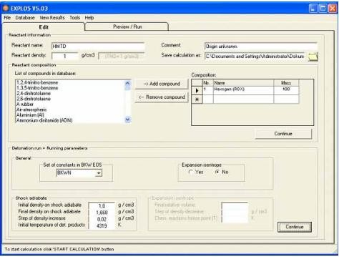

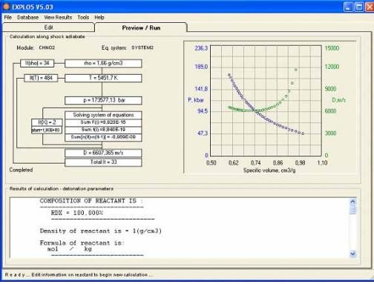

# Chapter 4 Composing Dataset

## Attributes Of Dataset:

**Name of Energetic Material :** The attribute "Name of Energetic Material" in refers to a specific field or column that contains information about the names of substances classified as energetic materials. Energetic materials are substances that release energy when subjected to certain stimuli, such as heat, shock, or impact. These materials are often used in various applications, including explosives, propellants, and pyrotechnics.

**Molar Mass (g/mol):** It refers to the molar mass of a substance, expressed in grams per mole (g/mol). Molar mass is a physical property of a chemical element or compound and represents the mass of one mole of that substance. It is commonly used in chemistry and is essential for various calculations in the field.

**Shock Sensitivity:** Shock sensitivity refers to how an explosive material responds to sudden mechanical shocks or impacts.

Explosive materials are sensitive to external stimuli, and shock sensitivity measures their susceptibility to detonation when subjected to sudden mechanical forces, such as impacts or shocks. Highly shock-sensitive explosives can detonate more easily under impact, posing greater safety risks during handling, transportation, or storage.

**Friction Sensitivity:** Friction sensitivity refers to how an explosive material responds to frictional forces.

Friction sensitivity measures the likelihood of an explosive material detonating when subjected to frictional forces, such as rubbing or abrasion. Materials with high friction sensitivity may be more prone to accidental detonation if they experience friction during handling or other processes. Understanding friction sensitivity is crucial for ensuring the safe manufacturing, storage, and handling of explosive materials.

**Carbon:** It is a chemical element with the symbol C and atomic number 6. It is a non- metal that is the fourth most abundant element in the universe by mass. Carbon is a key building block of life, forming the basis for organic chemistry and the structures of all known living organisms.

**Hydrogen :** It is a chemical element with the symbol H and atomic number 1. It is the lightest and most abundant element in the universe, constituting about 75% of its elemental mass.

**Oxygen :** It can play a crucial role in explosives by acting as an oxidizer. In explosive reactions, there is a rapid release of energy, often in the form of heat, light, sound, and the production of gases. Oxygen, as an oxidizer, supports the combustion of the explosive material, contributing to the overall reaction.

**Nitrogen** : It plays a significant role in explosives, often serving as a key component in various explosive compounds. Nitrogen-containing compounds are commonly used

in explosives due to their ability to release a large amount of energy during combustion or detonation.

Nitrogen is frequently incorporated into explosives in the form of nitro groups (-NO2). Nitro groups contain oxygen, and during the explosive reaction, they release energy by breaking the nitrogen-oxygen bonds and forming more stable nitrogen and oxygen gas molecules.

Examples of explosives with nitro groups include nitroglycerin (glyceryl trinitrate) and trinitrotoluene (TNT). Nitroglycerin, in particular, is highly sensitive and is often used as a primary explosive or as a component in dynamite.

#### Chemical Family : ("aromatic," "aliphatic," "inorganic")

The terms "aromatic," "aliphatic," and "inorganic" are used to classify chemical compounds based on their structural characteristics and composition. Here's a brief explanation of each chemical family:

**1.) Aromatic Compounds:** Aromatic compounds are a type of hydrocarbon that contains a cyclic structure with alternating single and double bonds. The most common example is benzene (C6H6).

**2.) Aliphatic Compounds:** Aliphatic compounds are hydrocarbons that do not contain an aromatic ring. They can be either saturated (alkanes) or unsaturated (alkenes and alkynes) and may have linear or branched structures.

**3.) Inorganic Compounds:** Inorganic compounds are compounds that do not contain carbon-hydrogen (C-H) bonds. While this definition is broad, it generally includes minerals, salts, metals, and other compounds that are not classified as organic.

Structural Feature: Inorganic compounds can have diverse structures and compositions, including ionic compounds, covalent compounds, and metallic compounds.

Example: Sodium chloride (NaCl), water (H2O), sulfuric acid (H2SO4), ammonia (NH3).

**Test Density :** Density is a fundamental property of matter and is often used to identify substances or materials. Objects with different densities will occupy different amounts of space for the same mass. For example, a material with a higher density will have more mass concentrated in a given volume compared to a material with lower density.

**Detonation Velocity :** Detonation velocity refers to the speed at which a detonation wave travels through an explosive material under specific conditions. It represents the rate at which the chemical reaction associated with the detonation process progresses within the explosive substance.

In an explosive event, the detonation process involves the rapid release of energy as the explosive material undergoes a chemical reaction, typically characterized by the decomposition of the explosive compound. The detonation wave is a shock wave that

travels through the explosive material, causing it to rapidly transition from a stable state to a highly reactive state.

Several factors can influence detonation velocity, including the type of explosive, the density of the explosive material, the confinement of the explosive, and environmental conditions. Detonation velocity is often measured in meters per second (m/s) or feet per second (ft/s).

Understanding detonation velocity is crucial in the design and analysis of explosive materials and their applications. Explosives with higher detonation velocities are generally more effective for certain purposes, such as in military or industrial applications where the rapid release of energy is desired. However, it's important to note that different explosives have varying detonation velocities, and the choice of explosive depends on the specific requirements of the intended use.

Collecting and cleaning a dataset are crucial steps in the data science process. Here's an explanation of each step:

#### Collecting a Dataset:

**Define Objectives:** Clearly define the objectives of your project and the specific data you need. Understand the research questions you want to answer or the problems you aim to solve.

**Identify Data Sources**: Identify potential sources of data based on your objectives. Sources can include publicly available datasets, proprietary databases, government agencies, research institutions, APIs, or data collected through experiments or surveys.

**Access and Download Data:** Access the selected data sources and download the relevant datasets. This may involve downloading files from websites, querying databases, or using APIs to retrieve data programmatically.

**Data Exploration:** Explore the structure and content of the dataset. Check for the number of rows and columns, data types, and a preliminary understanding of the variables. This step helps you gain insights into the data's characteristics.

**Data Documentation:** Document the source of each dataset, including any metadata, documentation, or codebooks that provide information about the variables, units, and other relevant details

#### Cleaning a Dataset:

**Handling Missing Values:** Identify and handle missing values in the dataset. Options include removing rows with missing values, imputing missing values with statistical measures (mean, median, mode), or using more advanced imputation methods.

**Dealing with Duplicates:** Check for and remove duplicate rows in the dataset. Duplicates can skew analysis results and model training.

**Addressing Outliers:** Identify and handle outliers that may impact the statistical analysis or machine learning models. Options include removing outliers or transforming the data to reduce their impact.

**Standardizing/Normalizing**: Standardize or normalize numerical features if they are on different scales. This ensures that all features contribute equally to the analysis or modeling process.

**Converting Data Types:** Ensure that variables have the correct data types. For example, categorical variables should be properly encoded, and date/time variables should be in a consistent format.

**Handling Categorical Variables:** Encode categorical variables using techniques like one-hot encoding or label encoding, depending on the nature of the data and the requirements of the analysis or modeling.

**Data Transformation:** Apply necessary transformations to the data based on the objectives. This may include feature engineering, creating new variables, or deriving insights from existing ones.

**Checking Consistency:** Ensure consistency across the dataset. For example, check that values in one variable align with the values in another variable, and correct any inconsistencies found.

**Checking Data Integrity**: Ensure data integrity by checking for logical errors or inconsistencies within the dataset. This may involve domain-specific checks or validation against external sources.

**Document Changes:** Document any changes made to the dataset during the cleaning process. This includes noting the reasons for specific decisions and transformations.

By carefully collecting and cleaning your dataset, you set the foundation for meaningful analysis and accurate model building in your data science project.

# Dataset 1

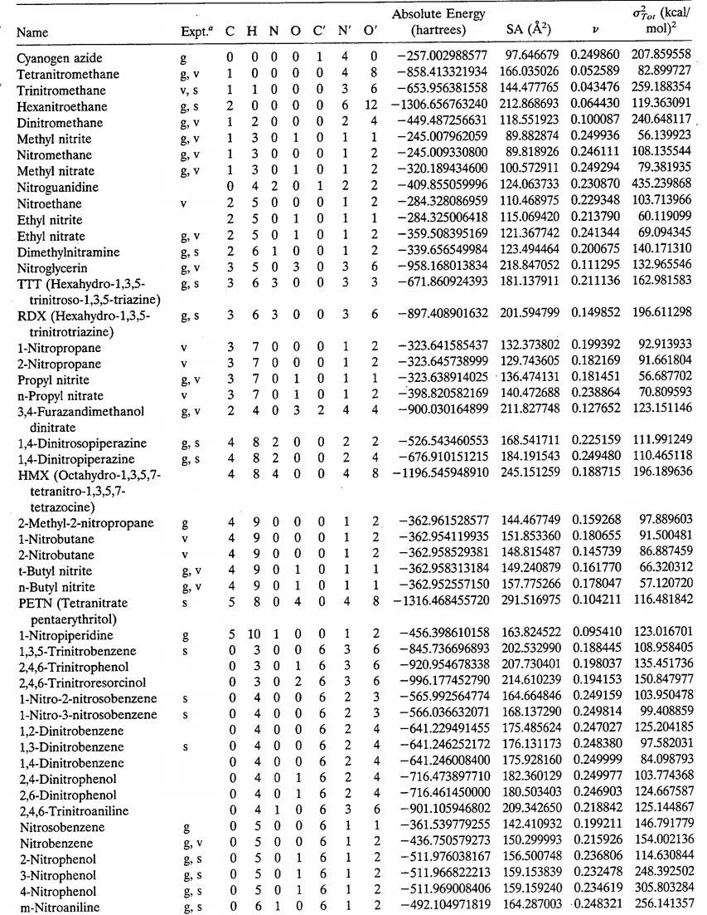

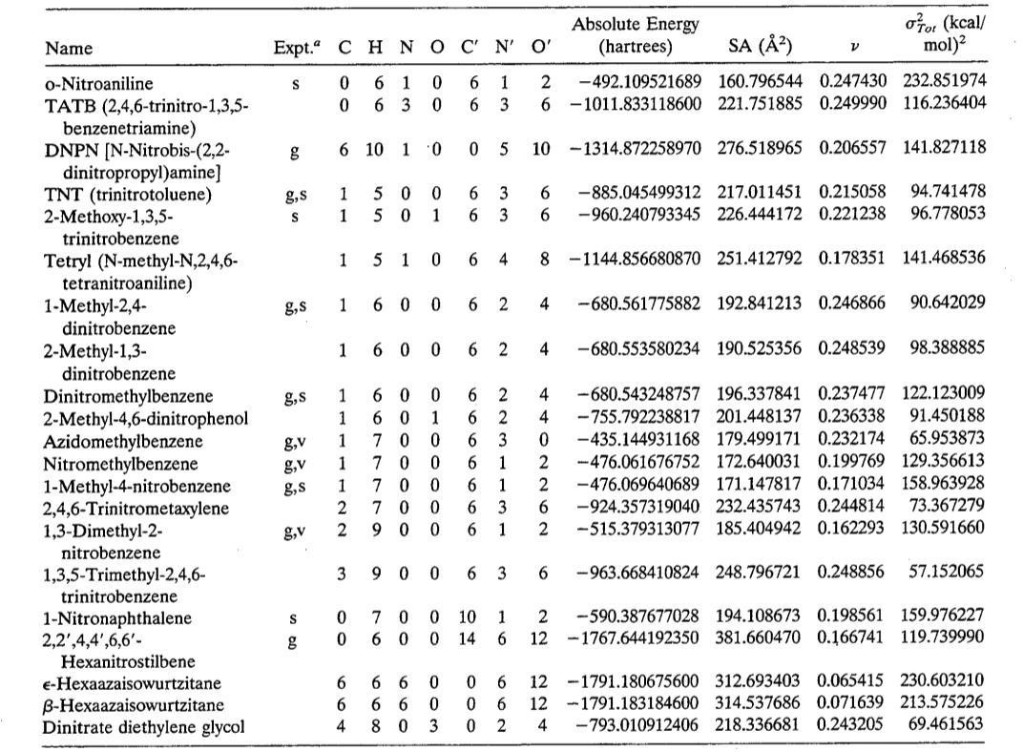

**Dataset 2**

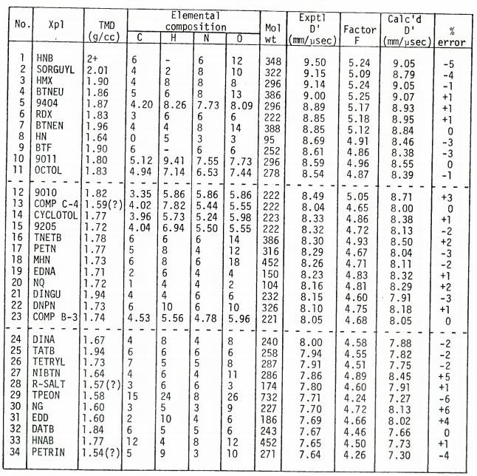

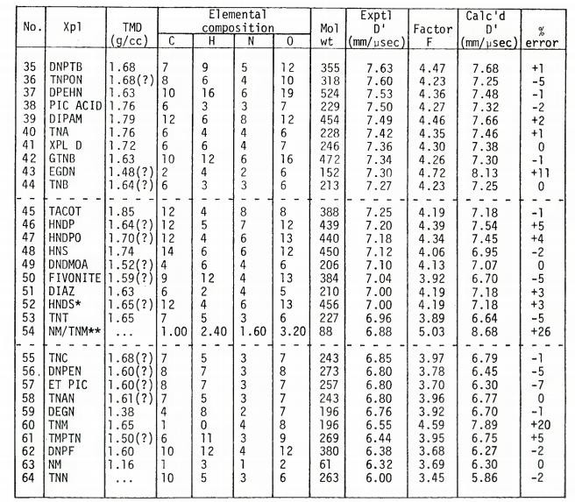

# Chapter 5 Prediction Process Technologies Used:

**Python:**

Python is a versatile and widely-used programming language that plays a crucial role in Machine Learning (ML) applications due to its rich ecosystem of libraries, ease of use, and flexibility. Here's an overview of how Python is utilized in ML:

#### Libraries and Frameworks

* + Python offers several powerful libraries and frameworks specifically designed for ML tasks. The most prominent ones include:
    - NumPy and SciPy: For numerical and scientific computing, essential for handling arrays, matrices, and mathematical operations.
    - Pandas For data manipulation and analysis, including handling structured data, data cleaning, and preprocessing.
    - Matplotlib and Seaborn: For data visualization, enabling the creation of plots, charts, and graphs to understand data patterns and distributions.
  + Scikit-learn: A comprehensive library for ML algorithms, including classification, regression, clustering, dimensionality reduction, and model evaluation.
* TensorFlow and PyTorch: Deep learning frameworks that allow the development and training of neural networks for complex ML tasks.

#### Ease of Prototyping:

* + Python's syntax and readability make it well-suited for rapid prototyping and experimentation in ML projects. Developers can quickly write and test code, iterate on algorithms, and explore different approaches without significant overhead.
  + Jupyter Notebooks, an interactive environment for Python, further enhances prototyping capabilities by enabling code execution, data visualization, and documentation in a single notebook interface.

#### Data Handling and Preprocessing:

* + Python's libraries, such as NumPy, Pandas, and SciPy, facilitate efficient data handling, preprocessing, and feature engineering tasks.
  + Data can be imported from various sources, cleaned, transformed, scaled, and prepared for training ML models using Python's data manipulation capabilities.

#### Machine Learning Algorithms:

* Python's Scikit-learn library provides a wide range of ML algorithms, including:
  + Supervised Learning: Classification (e.g., SVM, Decision Trees), Regression (e.g., Linear Regression, Random Forests), Ensemble methods.
  + Unsupervised Learning: Clustering (e.g., K-means, DBSCAN), Dimensionality Reduction (e.g., PCA, t-SNE).
* These algorithms are implemented in Python and offer easy-to-use interfaces for training, testing, and evaluating models.

#### Deep Learning and Neural Networks:

* + Python's deep learning frameworks, such as TensorFlow and PyTorch, enable the development and training of complex neural network architectures.
* These frameworks provide APIs for building deep learning models, handling large datasets, GPU acceleration for faster computations, and deployment options for production environments.

#### Model Evaluation and Optimization:

* + Python libraries offer tools for model evaluation, hyperparameter tuning, cross- validation, and performance metrics calculation.
  + Scikit-learn provides functions for model selection, grid search, and pipeline construction, making it easier to optimize ML models for better performance.

#### Integration with Other Technologies:

* Python's versatility allows seamless integration with other technologies and tools commonly used in ML projects, such as databases (SQL and NoSQL), web frameworks (Flask, Django), cloud platforms (AWS, Azure), and big data processing frameworks (Spark).

In summary, Python's widespread adoption in the ML community is attributed to its powerful libraries, ease of use, rapid prototyping capabilities, extensive support for data handling and preprocessing, rich collection of ML algorithms, deep learning frameworks, model evaluation tools, and integration with various technologies. Python continues to be a preferred language for ML practitioners and researchers due to its effectiveness in developing robust and scalable ML solutions across diverse domains.

**1. Detonation Velocity**

A straightforward, empirical linear correlation is proposed between detonation velocity and a parameter denoted as F, which is determined solely by the chemical composition and structure of a range of explosives. Because detonation velocity,

represented as DQ, is influenced by density, the linear regression plot (Figure 1) of the parameter F against detonation velocity is constructed using velocities either directly measured or adjusted to match those achievable at the theoretical maximum density (TMD) of the explosive under examination. These adjusted velocities, denoted as D', are estimated from the equation D' = Do + (PT-M TM - Po) X 3.0, where D', PT-M, DQ, and PQ represent detonation velocities and densities at their respective theoretical maximum and experimentally measured values, expressed in millimeters per microsecond (mm/μs) and grams per cubic centimeter (g/cc).

The key aspect of this relationship is that F values are determined solely based on molecular formulas and structures, eliminating the need for prior knowledge of any physical, chemical, or thermochemical properties measured, estimated, or calculated

.

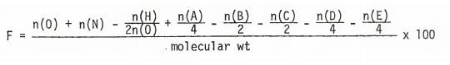

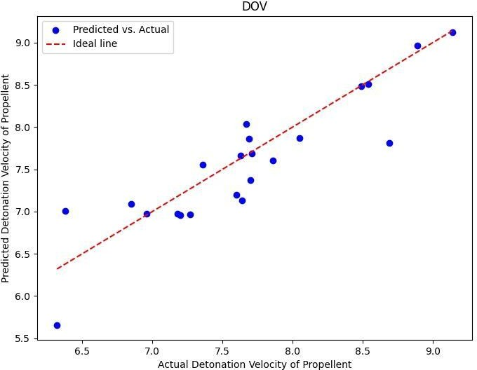

# Code.

import pandas as pd import numpy as np

import matplotlib.pyplot as plt

from sklearn.metrics import mean_squared_error dataset = pd.read_excel("anu.xlsx")

x = dataset.iloc[:,1:7] print(x.head())

y = dataset.iloc[:,7]

# SPLITTING THE TEST AND TRAIN DATA

from sklearn.model_selection import train_test_split

X_train , X_test , y_train , y_test = train_test_split(x, y, test_size=1/3, random_state=0)

def Linear_Regression():

from sklearn.linear_model import LinearRegression regressor = LinearRegression() regressor.fit(X_train,y_train)

print("LINEAR REGRESSION")

y_pred_train = regressor.predict(X_train)

mse_train = mean_squared_error(y_train, y_pred_train) rmse_train = np.sqrt(mse_train)

print("Linear Regression Train:", mse_train, rmse_train)

y_pred_test = regressor.predict(X_test)

mse_test = mean_squared_error(y_test, y_pred_test) rmse_test = np.sqrt(mse_test)

percentage_error = np.abs((y_test - y_pred_test) / y_test)

* 100

average_percentage_error = np.mean(percentage_error) print("Linear Regression Test :", mse_test, rmse_test,

average_percentage_error)

print("

")

plt.figure(figsize=(8, 6))

plt.scatter(y_test, y_pred_test, color='blue', label='Predicted vs. Actual')

plt.plot([min(y_test), max(y_test)], [min(y_test), max(y_test)], color='red', linestyle='--', label='Ideal line')

plt.title('DOV')

plt.xlabel('Actual Detonation Velocity of Propellent') plt.ylabel('Predicted Detonation Velocity of Propellent') plt.legend()

plt.show() # DECISION TREE

def Decison_Tree():

from sklearn.tree import DecisionTreeRegressor tree_regressor = DecisionTreeRegressor(random_state=45) tree_regressor.fit(X_train, y_train)

y_pred_train = tree_regressor.predict(X_train) y_pred_test = tree_regressor.predict(X_test) print("DECISON TREE")

mse_train = mean_squared_error(y_train, y_pred_train) rmse_train = np.sqrt(mse_train)

print("Decison Tree Train: ", mse_train, rmse_train)

percentage_error = np.abs((y_test - y_pred_test) / y_test)

* 100

average_percentage_error = np.mean(percentage_error) mse_test = mean_squared_error(y_test, y_pred_test) rmse_test = np.sqrt(mse_test)

print("Decison Tree Test : ", mse_test, rmse_test, average_percentage_error)

print("

")

# RANDOM FOREST

def Random_Forest():

from sklearn.ensemble import RandomForestRegressor

print("RANDOM FOREST")

random_forest_regressor = RandomForestRegressor(n_estimators=200, random_state=42)

random_forest_regressor.fit(X_train, y_train.ravel()) y_pred_train = random_forest_regressor.predict(X_train) y_pred_test = random_forest_regressor.predict(X_test)

mse_train = mean_squared_error(y_train, y_pred_train) rmse_train = np.sqrt(mse_train)

print("Random Forest Train: ", mse_train, rmse_train)

mse_test = mean_squared_error(y_test, y_pred_test) rmse_test = np.sqrt(mse_test)

percentage_error = np.abs((y_test - y_pred_test) / y_test)

* 100

average_percentage_error = np.mean(percentage_error)

print("Random Forest Test : ", mse_test, rmse_test) print("Random Forest Percentage error : ",

average_percentage_error)

print("

")

def Neural_Network(X_train, X_test, y_train, y_test): import tensorflow as tf

from tensorflow import keras

from sklearn.preprocessing import StandardScaler scaler = StandardScaler()

print("NEURAL NETWORK")

X_train = scaler.fit_transform(X_train) X_test = scaler.transform(X_test)

model = tf.keras.Sequential([ tf.keras.layers.Dense(64, activation='relu',

input_shape=(X_train.shape[1],)), tf.keras.layers.Dense(32, activation='relu'), tf.keras.layers.Dense(1) ])

model.compile(optimizer='adam', loss='mean_squared_error') model.fit(X_train, y_train, epochs=100, batch_size=30,

validation_split=0.1)

y_pred = model.predict(X_test).flatten()

mse = mean_squared_error(y_test, y_pred) rmse = np.sqrt(mse)

percentage_error = np.abs((y_test - y_pred) / y_test) *

100

average_percentage_error = np.mean(percentage_error) print("Neural Network", mse, rmse,

average_percentage_error)

Linear_Regression() # Decison_Tree()

# Random_Forest()

# Neural_Network(X_train, X_test, y_train, y_test)

# Results:

**1st Pass**

LINEAR REGRESSION

Linear Regression Train: 908573.2236536817 953.1910740526695

Linear Regression Test : 2469862.8.21727828 1571.5814383220106

12.8.00612576453439

DECISON TREE

Decison Tree Train: 0.0 0.0

Decison Tree Test : 3861822.7.75 1962.5.1533655162896 22.5.524942724422587

RANDOM FOREST

Random Forest Train: 275946.89616774203 522.5.3064783226474

Random Forest Test : 1206042.8.0261750002 1092.8.202179097729

Random Forest Percentage error : 12.4.382223421760832

# 2nd Pass after major Optimizations

|  |  |
| --- | --- |
| Linear Regression Test :  Mean Square Error : | 0.122018746 |
| Root Mean Square Error : | 0.349311819 |
| Average Error : | +- 3.533522673 |
| Decison Tree Test : Mean Square Error : | 0.405409090 |
| Root Mean Square Error : | 0.636717434 |
| Average Error : | +- 2.5.887777894 |
| Random Forest Test : Mean Square Error : | 0.328541947 |
| Root Mean Square Error : | 0.573185787 |
| Average Error : | +- 2.5.597910635 |

The Best Results that we are getting is from Linear Regression which is about 87 - 96 % Accuracy.

# Conclusion

In my capacity at DRDO, I am deeply engaged in a pioneering endeavor that merges the cutting-edge capabilities of Machine Learning (ML) with the intricate realm of High-Energy Materials (HEMs). This dynamic fusion allows us to delve into the complexities of HEM properties with unprecedented depth, leveraging ML algorithms to unravel intricate patterns, relationships, and behaviors within these materials. By harnessing the power of data-driven insights, we are not only optimizing synthesis processes and predicting performance characteristics with remarkable accuracy but also accelerating the pace of material design iterations, leading to rapid advancements in HEM research and development.

The impact of this work extends far beyond the confines of our laboratories. It heralds a new era in material science and defense technology, where ML-driven innovations in HEMs are poised to revolutionize multiple sectors. The optimized synthesis processes and predictive models we are developing have the potential to transform the landscape of defense systems, aerospace technologies, energy storage solutions, and beyond. These advancements will not only bolster national security capabilities but also contribute significantly to technological advancements globally.

Furthermore, the integration of ML with HEM research sets the stage for continuous innovation and disruptive breakthroughs in high-performance materials and systems. As we refine our understanding, refine our methods, and unlock new insights at the intersection of ML and HEMs, we are laying the foundation for a future where materials are designed with unparalleled precision, efficiency, and effectiveness. This convergence of expertise and technology promises to shape the trajectory of scientific discovery, engineering excellence, and national defense strategies for years to come.